LED control card

User Manual

Before you use the LED controller, please read this file first and save it for future. questions.

BX-6Q3

Statement

Any companies or privates cannot copy, transcribe or translate part or whole content of this file without our written permission. And cannot use it on any business or benefit filed with any forms.
The specifications and information which are mentioned on the file is for reference only, if there’s update, we will not inform you. This file is only for guidance, and all information will not be for any promises.

CATALOG

Brief Introduction 1
About Software 1
Guiding 2
Safety Notes 2
Function Introduction 3
Control Area 3
Dynamic Area 3
Areas in on program 3
Send programs by many platforms 3
Support APP 3
Cluster sending programs 4
Send program in timing 4
Turn on/off in timing 4
Test button 4
Auto correction 4
IR controller 4
Switch program by button 4
Colorful frame and background 5
Sensors 5
Multi languages 5
SDK 5
Technical Specifications 6
Size 7
Left panel icon 8
Right panel icon 9

Brief Introduction

Thanks for ordering LED control card. The design of the control card is according to the international and industrial standard, but if the operations are incorrect, it will probably bring you personal injury and financial harm. As to avoid these and win more from your equipment, please obey the specifications of this file.

About Software

Cannot do any modification, decompilation, disassembling, decoding or reverse engineering on our software, it’s illegal.

Characteristics

- Used for super long lintel full color screen and cluster control, one card for one screen.
- Text moving smoothly, abundant text types, like: vertical words, gradient words, colorful words.
- Overlay functions by the abundant background effects and colorful texts.
- High refreshment, high gray scale, and support animation, video.
- The best technology and stable quality. 3.5V-6V , -40℃～80℃ working temperature.
- Support firmware update online.
- Support cluster management, multi programs editing, multi areas display and multi languages.
- Support temperature, temperature&humidity and brightness sensor.
- Support playing program, lock screen, adjust brightness, turn on/off, test screen by IR controller.
- Can edit , send and control screen on iLEDCloud.
- Support 512 programs and each program has 16 areas
- Support graphic, subtitle, animation, time, dial, timer, temperature, temperature&humidity, weather broadcast.
- Support colorful program frames and area frame.

Guiding

Safety Notes

- Input voltage is 5V, voltage range is from 3.5V-6V, please make sure the quality of the power supply of BX-6Q series.
- Please make sure that all the power supply cables are plugged off when you want to connect or plug off any signal or controlling cables.
- Please make sure that all the power supply cables and signal cables are plugged off when you need to put in or take off the hardware equipment.
- Please take off the power supply of LED video processor before you do any hardware operations, and ESD by touching the ground.
- Please make sure the environment is clean, dry and ventilated when you use this product, also, do not put this product to a high temperature and wet environment.
- This product is electronic products, please keep away from fire, water source and flammable&combustible products.
- There’s high pressure components in this products, please do not open the box and repair it by yourself.
- Turn off the power supply immediately when you find smoking, peculiar smell or something unusual. And contact with us soon.

Function Introduction

The release of BX-6Q brings a good feedback from the market, and it is now the main stream of LED lintel full color screen and LED advertising box. With 100M LAN port on board, USB port and 4 GB FLASH.

Control Area
Total pixels≤384K，384*1024、512*768、1024*384、2048*192、3072*128、4096*96、6144*64、 12288*32.

Dynamic Area
We offer C#, java, SDK, VB, C++ for static and dynamic area; Static area support “save the data when power is off”; Support 32 graphic areas, including colorful words and background, each static area is not conflicted; We offer protocol for dynamic area too, support 32 dynamic area (the storage of each area is 1M), it won’t save when the power is off. Dynamic area can relate to many static areas, offer many playing modes.

Areas in on program
Users can add areas in one program as their requirements: graphic, subtitle, time, animation, frame areas and so on.

Send programs by many platforms
When you finish the editing of all the programs, you send program by LedshowTW directly, or by iLEDCloud. ILEDCloud is offered by onbon, the corn is Alibaba cloud, which is reliable and stable. To use this platform, users only need a browser, then, can edit program by remote control, preview program and play the program in a fixed time. Also, users can log in the iLEDCloud by mobile phone, pad and pc.

Support APP
Users can install APP software “ledshow”, by APP, users can search, add screens automatically, turn on/off, brightness, volume, etc. Edit program, add video, text, graphic, time area, timer area, send program, share program,etc. For software, it supports play in multi lines, dynamic preview, multi languages, video transcoding, optimize video effect and support zoom in and out by fingers. “Ledshow” support not only YQ series, but also 5th and 6th generation and 6Q lintel full color control cards.

Cluster sending programs
This product used for all kinds of cluster systems on LED lintel full color screen and LED advertising boxes. By the stable and high efficient LAN mode, users can control , manage and maintain the screens which are in different areas, as to realize the cluster sending programs.

Send program in timing
Users can set the time you want to send the program, then, the program will be sent according to the time you set.

Turn on/off in timing
The function of “timing turn on/off”, users can set the time you want to turn on and the time you want to turn off. If users are not convenient to operate all the time, that will be the best choice.

Test button
The screen display will be worse if the led screen has been used for a long time, so, it needs test in a fixed time. With the function of “test button”, users can test the broken lamps, brightness and colors by several steps.

Auto correction
The system will do correction automatically, like our mobile phone and computer. So, users do not need to do it manually.

IR controller
Users can select programs , turn on/off screen by IR controller. Also you can adjust the screen brightness, and test the screen.

Switch program by button
Users can also switch the programs by button on the board.

Colorful frame and background
The software offers many kinds of colorful frames and backgrounds.

Sensors
We offer temperature, temperature&humidity, and brightness sensor for users, as to avoid the losses by unknown temperature, humidity and brightness.

Multi languages
Software supports many languages like Chinese, English, French, German, Greek language, Russian, Japanese and so on.

SDK
Support SDK on static area and dynamic area. We offer you C#, java,SDK,VB,C++; We also offer you the completed SDK port and technological service.

Technical Specifications

Screen index
Parameters | Specification
Control size | 384*1024、512*768、1024*384、2048*192、3072*128、4096*96、6144*64、12288*32
Total pixels | 384K
The maximum width | No limit
The maximum height | 1024

Details
Input power | 5V(3.5V-6V), please make sure the quality of your power supply
Voltage | ≤4W
Working temperature | -40℃～80℃
Size | 93mm96.6mm27mm

Technical parameters
Storage | 4GByte
Gray scale | 65536 grade
Usage | Use on lintel full color screen and cluster control, one card for one screen
Software function | cluster management/edit multi programs/display multi areas/multi languages
Program type | normal program/share program
Program quantity | Support 512 programs, each program supports 16 areas
Area type
Dynamic area | Support 4 dynamic areas, the storage of each dynamic area is 1M
Frame | Colorful program frame and area frame
Background | Colorful background
Subtitle | vertical words, gradient words, colorful words
Clock | Dial/Chinese&English clock/timer (all support many groups)
Communication port | Standard 100M LAN port and USB port, support 3G wireless transmitting
Sensor | temperature/temperature&humidity/brightness
IR controller | Select program/lock screen/adjust brightness/turn on&off/test screen
Adjust brightness | 16 grade brightness, support adjust brightness by different time automatically/adjust brightness on software/adjust brightness by IR controller/adjust brightness automatically
Turn on/off remotely | Support turn on&off in timing/turn on&off on software/turn on&off by IR controller
SDK | Offer DLL; Offer C#,java,SDK,VB,C++
Software | LedshowTW (after version V16.06.06.00)
User manual | BX-6Q User manual

Size
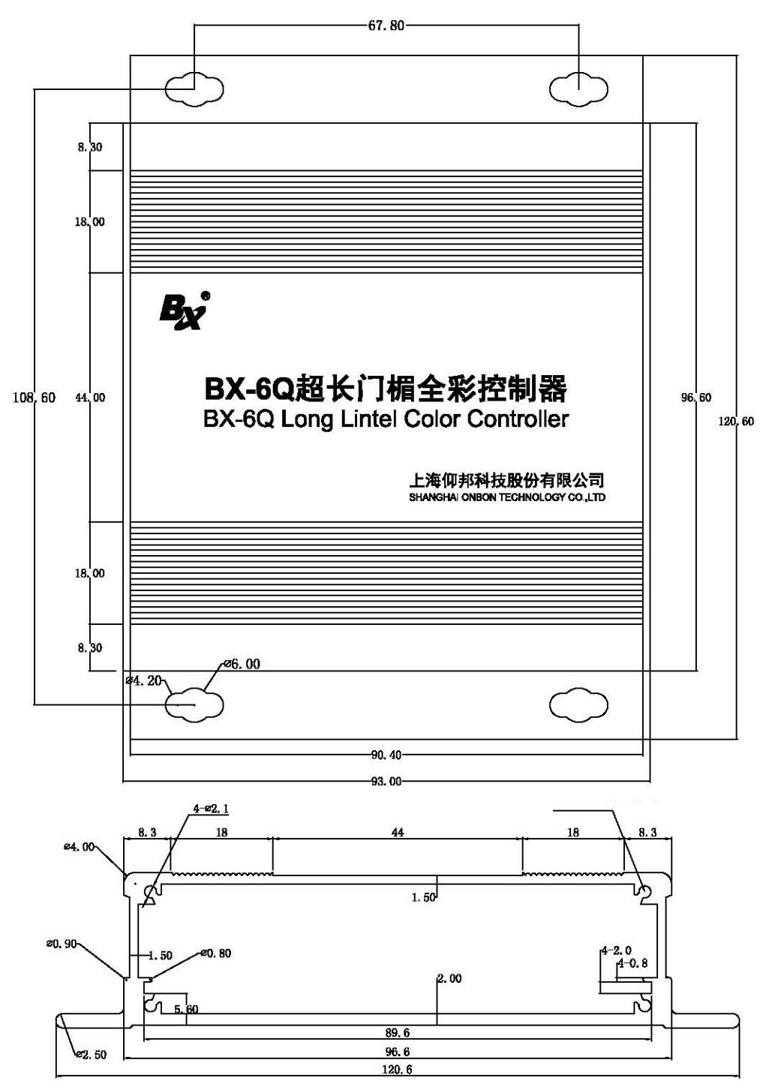

Left panel icon

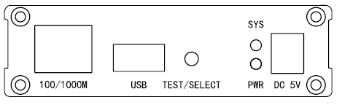

100/1000M interface
100/1000M | Ethernet interface ,communicate with computer

USB interface
USB | USB interface ，support USB port transmit programs

TEST/SELECT button
TEST/SELECT | Screen test button

SYS indicator
SYS | System indicator

PWR indicator
PWR | Power indicator

Power supply
DC5V | 5V (3.5V-6V)

Right panel icon

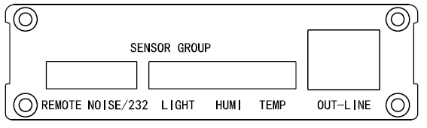

按键说明
REMOTE | Remote controller interface
NOISE/232 | Noise sensor interface
LIGHT | Brightness sensor interface
HUMI | HUMI sensor interface
TEMP | Temp sensor interface
OUT-LINE | Scan data output port , connect with full color receiving card

Contact Us

Shanghai ONBON Technology Co.,ltd (Headquarters)
Address: 7 Floor, Tower 88, 1199#, North Qinzhou Road, Xuhui District, Shanghai City, China
Tel Phone: 086-21-64955136
Fax: 086-21-64955136
Website: www.onbonbx.com

ONBON (Jiangsu) Optoelectronic Industrial Co.,LTD
Address: 1299#, Fuchun Jiang Road, Kunshan City, Jiangsu Province, China

Sales Contacts
Tel: 0086-15921814956 0086-15800379719
Email: onbon@onbonbx.com

Second Development
Tel: 0512-66589212
Email: dev@onbonbx.com

iLEDCloud
Website: http://www.iledcloud.com/

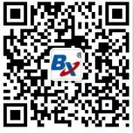
Public Wechat ONBON APP

